**Reviewers: Use this BSP for paint-only contracts when no new bridge plans are provided. Define coating limits clearly in section 2.2. Remove sections 2.3 and 2.4 if not required. Accept all revision marks if System G Overcoat is included in project, reject all revision marks if System G Overcoat is not included in project.**

STRUCTURAL STEEL PROTECTIVE COATING REQUIREMENTS 11/13/24

**1.0 Description.** This provision contains the requirements for applying the structural steel protective coating for the bridge(s) in this project.

**2.0 Construction Requirements.**

**2.1 System G.** System G shall be in accordance with Sec 1081. Surface preparation of the existing steel shall be in accordance with Sec 1081 for Recoating of Structural Steel (System G, H or I) with organic zinc primer or Sec 1081 for Overcoating of Structural Steel. The color of the field coats shall be Gray (Federal Standard #26373).

**2.2 Coating Limits.** All existing structural steel shall be recoated with System G.

**2.3. Expansion Joint Locations.**  The surfaces of all structural steel located under the joint(s) indicated in the table below shall be field coated with complete System G within a distance 1.5 times the girder depth, but not less than 10 feet from the centerline of joint each direction or not less than 10 feet from front face of backwall of end bent. Complete System G includes field application of organic zinc primer, intermediate field coat and finish field coat.

| **Bridge No.** | **Joint Location** |
| --- | --- |
| A04601 | None |
| A05091 | Bent No. 1 |
| A05241 | Bents No. 1 & 4 |
| A07631 | Bent No. 5 |
| X07581 | None |

**2.4 Limits of Paint Overlap.** System G shall overlap the existing coating between 6 inches and 12 inches in order to achieve maximum coverage at the paint limit of each complete system near the expansion and contraction areas. The final field coating shall be masked to provide crisp, straight lines and to prevent overspray beyond the overlap required.

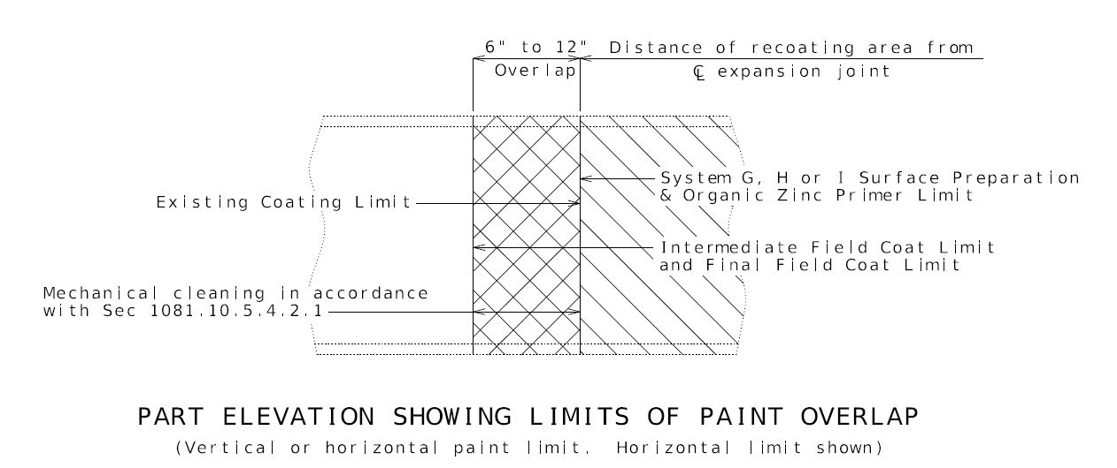

**3.0 Method of Measurement.**

**3.1 System G.** The surface preparation, prime coat and intermediate and finish field coats will be measured to the nearest 100 square feet in accordance with Sec 712 and the Limits of Coating Application in accordance with Sec 1081.

**4.0 Basis of Payment.** Payment for the above described work, including all material, equipment, labor and any other incidental work necessary to complete this item, will be considered completely covered by the following pay items:

Surface Preparation for Overcoating Structural Steel (System G) per square foot.

Surface Preparation for Recoating Structural Steel per square foot.

Field Application of Organic Zinc Primer per square foot.

Intermediate Field Coat (System G) per square foot.

Finish Field Coat (System G) per square foot.