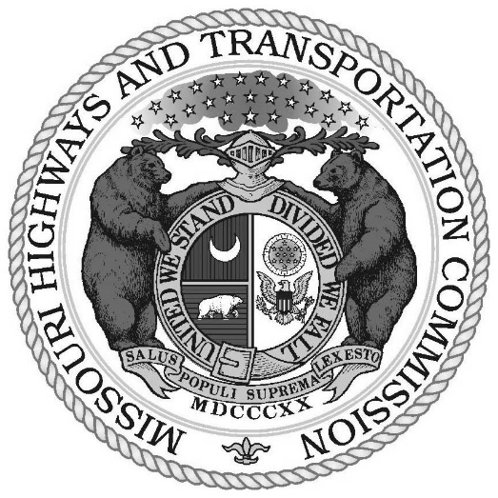**Missouri Highways and Transportation Commission**

**Official Minutes**

**Table of Contents**

**March 4, 2025**

VOTE TO CLOSE MEETING 4

**Minutes of the SPecial highways and transportation**

**commission meeting HELD in Jefferson City, Missouri, and VIa teams**

**TuesDAY, March 4, 2025**

A special meeting of the Missouri Highways and Transportation Commission was held on Tuesday, March 4, 2025, at the Missouri Department of Transportation, 105 W. Capitol Avenue, Jefferson City, Missouri. W. Dustin Boatwright, P.E., Chairman, called the meeting to order at 2:00 p.m. The following Commissioners were present: Gregg C. Smith, Warren K. Erdman, and Ann Marie Baker. Daniel J. Hegeman and Francis G. Slay were present via WebEx.

The meeting was called pursuant to Section 226.120 of the Revised Statutes of Missouri, as amended. The Secretary verified that notice of the meeting was posted in keeping with Section 610.020 of the Revised Statutes of Missouri, as amended.

* * * * * * *

* * * * * * *

Ed Hassinger, Director of the Missouri Department of Transportation; Terri Parker, Chief Counsel; and Jennifer Jorgensen, Secretary to the Commission, were present on Tuesday, March 4, 2025.

* * * * * * *

*“Department” or “MoDOT” herein refers to Missouri Department of Transportation.*

*“Commission” or “MHTC” herein refers to Missouri Highways and Transportation Commission.*

**-- Closed Meeting –**

## VOTE TO CLOSE MEETING

The agenda of the closed meeting was posted in keeping with Sections 610.020 and 610.022, RSMo, including the following statutory citations allowing the meeting to be closed:

1. Section 610.021(1) – Legal actions and attorney-client privileged communications.
2. Section 610.021(3), (13) – Personnel administration regarding particular employees.
3. Section 610.021(11), (12) – Competitive bidding specs, sealed bids, or negotiated contracts.

Upon motion duly made and seconded to convene in closed session, the Chairman called for a voice vote of the members. The vote was as follows:

Commissioner Boatwright, Aye

Commissioner Erdman, Aye

Commissioner Smith, Aye

Commissioner Hegeman, Aye

Commissioner Slay, Aye

Commissioner Baker, Aye

The Commission met in closed session on Tuesday, March 4, 2025, at 2:05 p.m. and adjourned at 5:30 p.m.

* * * * * * *

* * * * * * *

By unanimous consensus of all members present, the meeting of the Commission adjourned.

* * * * * * *

* * * * * * *

**The Mission of the Missouri Highways and Transportation Commission is to:**

* Represent the citizens of Missouri pursuant to the Constitution by providing independent and nonpartisan governance of the Missouri Department of Transportation; and
* Establish policies, exercise oversight, and ensure accountability in developing and maintaining a world class transportation system in Missouri which fosters safety and economic development.

* * * * * * *