E2O Compatibility
Quick Reference Guide

Contents
Contents 1
Unblock macros for excel file downloaded from the internet 2
Macro Buttons Not Working 3
Enable ActiveX Controls 3
Switch to Classic Outlook 7

Overview & Purpose

The Excel2Oracle forms (including the Contractor Reporting Excel2Oracle (CRE2O) excel forms) may require additional steps to get the forms to work depending on the version of outlook in use and various excel settings. This guide details some of the common issues & remedies:

- Unblock macros for excel file downloaded from the internet
- Macro buttons not working
  - Check “optimize for compatibility” under Excel’s general options
    - Generally error occurs for user with multiple monitors, this can fix the issue
- Enable activex controls
- new outlook doesn’t work with “outlook client upload” button on Send/Sync tab
  - user needs “classic outlook” open for the “Outlook Client Upload” button to work
  - user with “new outlook” needs to manually email file to awpcre2o@modot.mo.gov
    - excel’s insert tab has an email button for sending the excel file, this may be a more user-friendly approach for manually emailing the CRE2O sheet into MoDOT
      - this button may work better if the user has the excel file saved in one drive/sharepoint but we have not tested this to be sure one way or the other
- Office 365 vs older versions of excel
  - Concrete mix design E2O sheet uses office 365 functions. E2O sheet will not work if shared with someone without office 365
    - Older versions of excel don’t have the filter/unique/xlookup functions used by the concrete mix design sheet to generate picklists

Unblock macros for excel file downloaded from the internet
- Navigate to the saved file in windows file explorer
- Under properties – check “Unblock” then “apply”
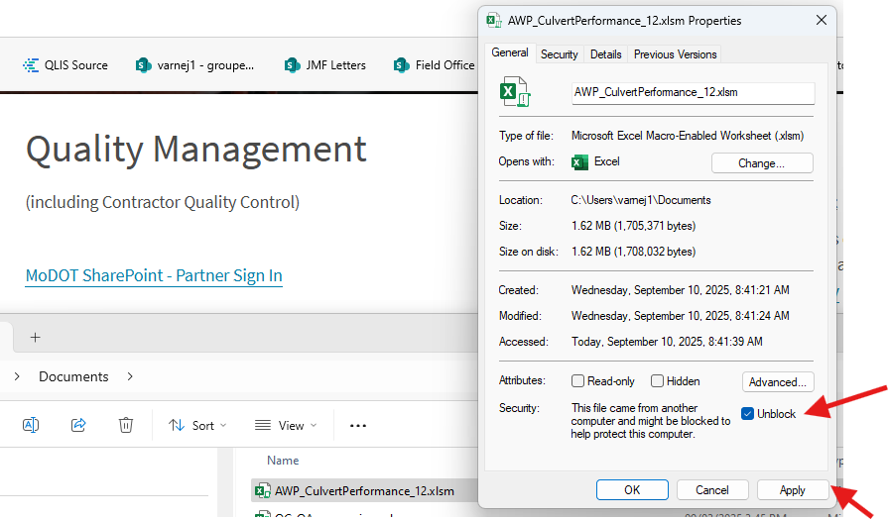

Macro Buttons Not Working
- Generally occurs if user has multiple monitors
- Check “optimize for compatibility” under excel’s general settings:
  - Listed under “User Interface Options” subheading
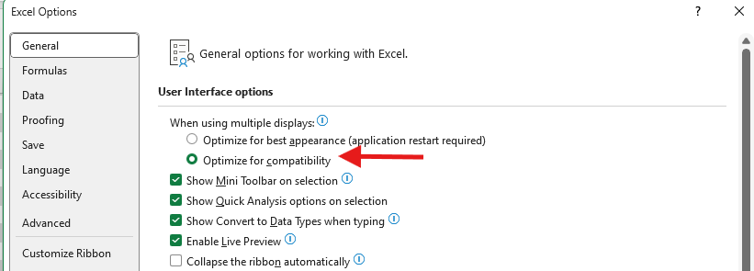

Enable ActiveX Controls
Navigate to “ActiveX Settings” as follows:
- File
- Options
- Trust center
- Trust center settings
- activeX settings
- select “Prompt me before enabling all controls with minimal restrictions”
- close excel completely
- re-open excel file you want to edit

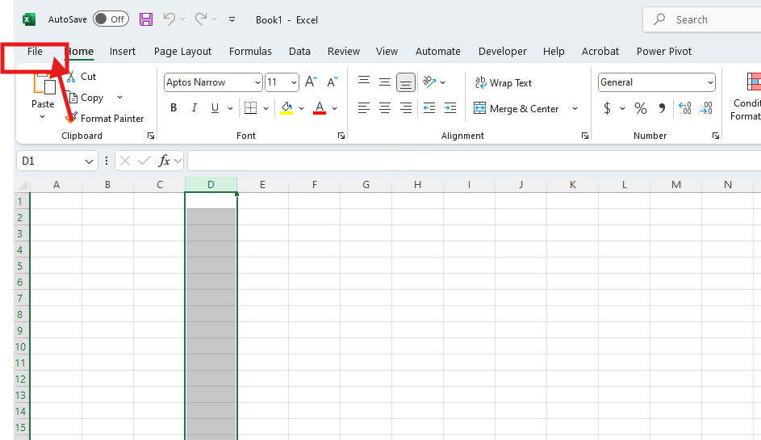
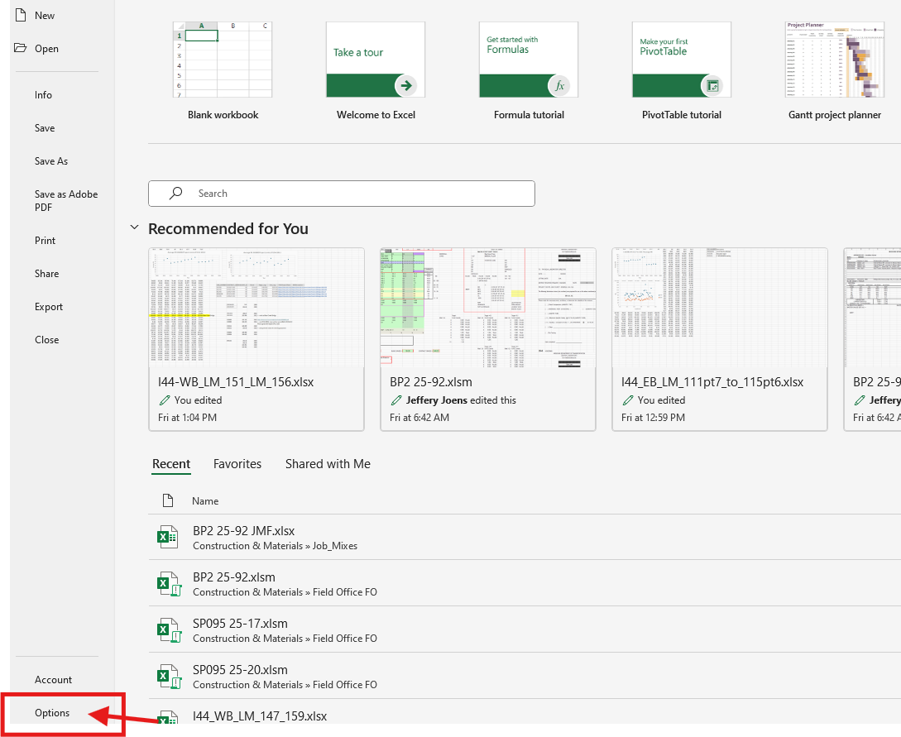
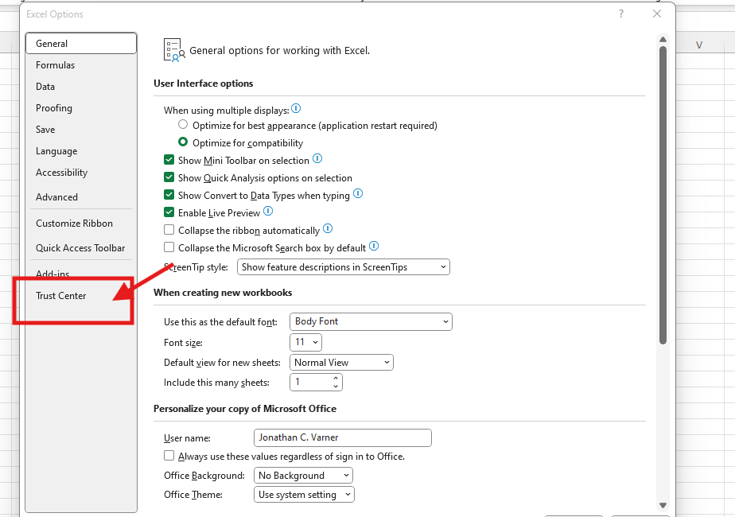
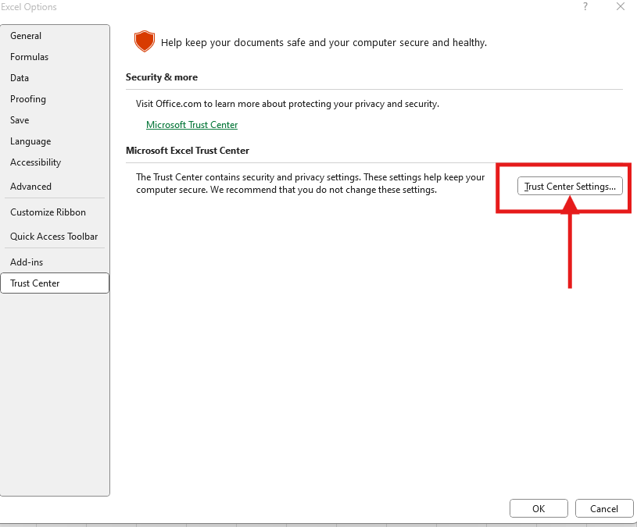
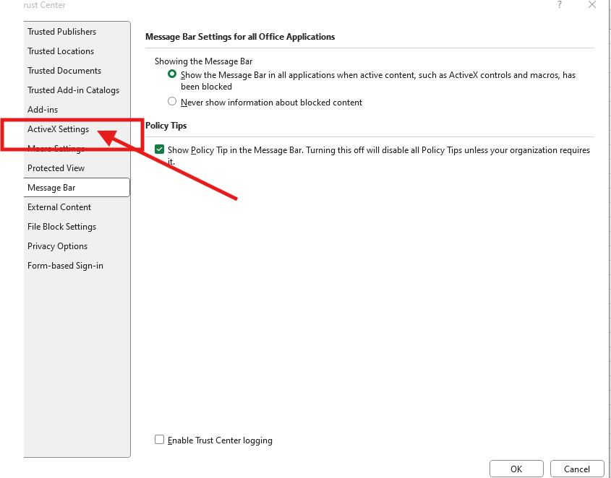

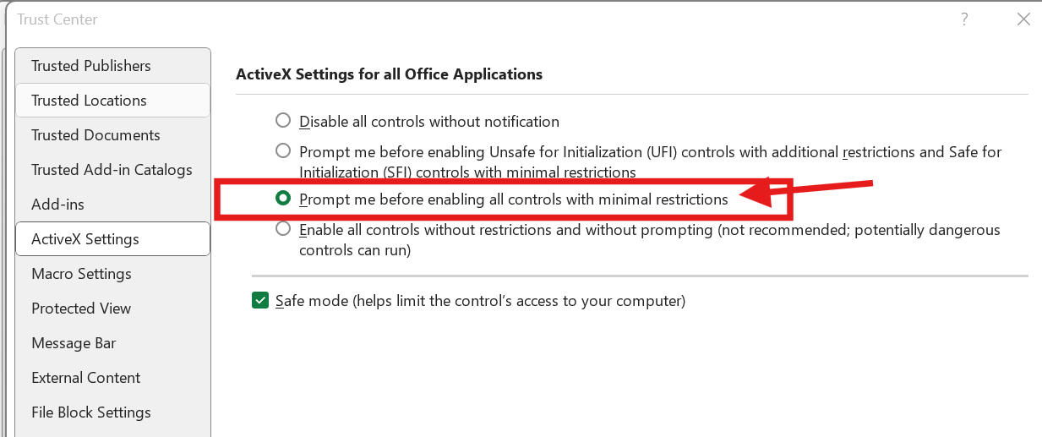

Switch to Classic Outlook
The “Outlook Client Upload” button works only if the user has “Classic Outlook” open. If Classic Outlook is not an option then users will have to manually send an email to awpcre2o@modot.mo.gov with the excel file attached. “Outlook Client Upload” is the preferred approach

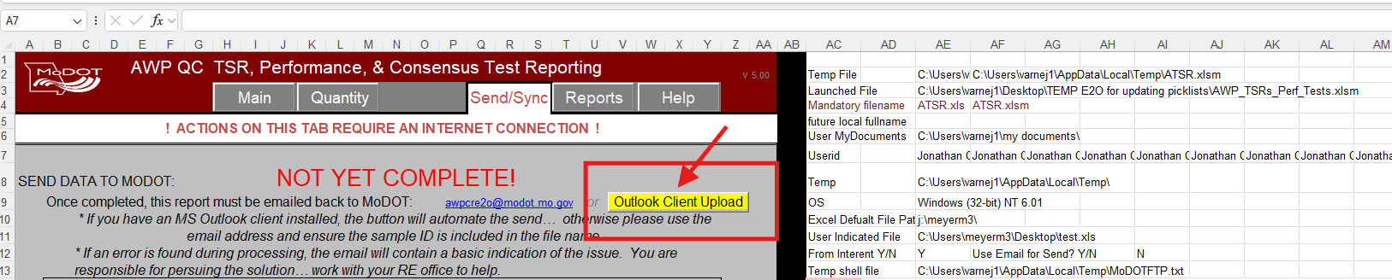
“new outlook” doesn’t support this method
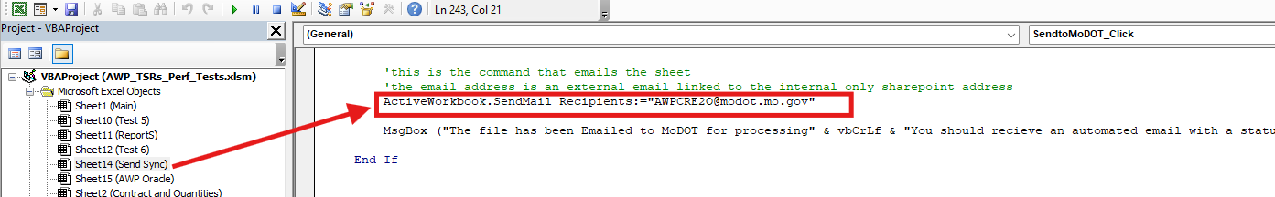
In new outlook, click either of the two buttons below:
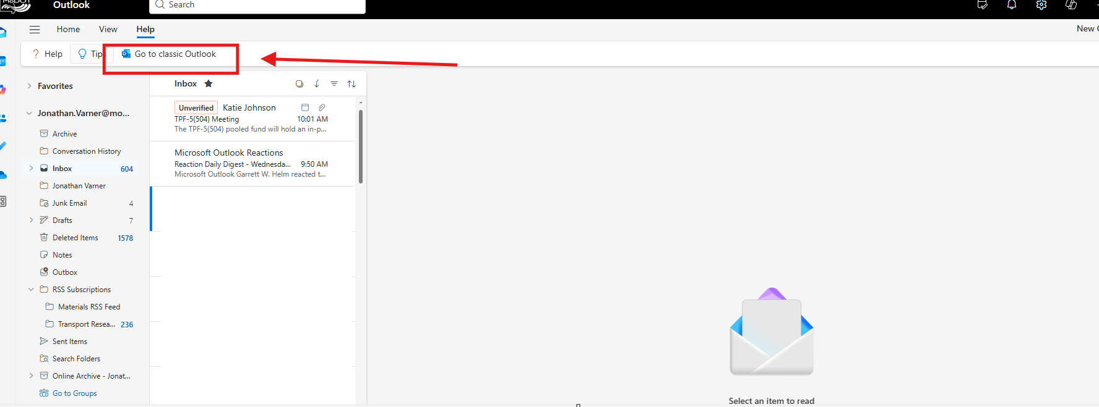
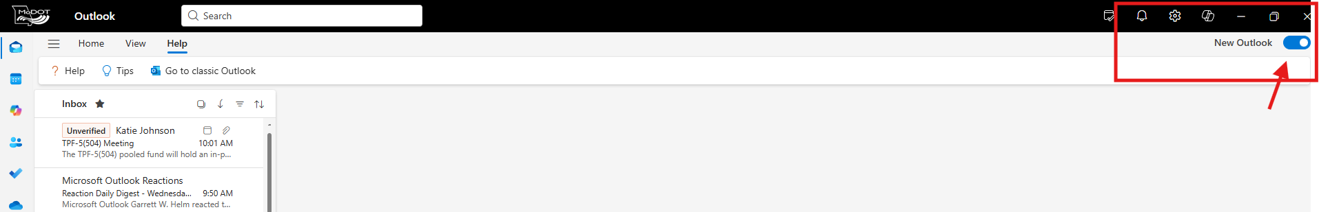
On clicking following screen should show up, then “classic Outlook” should open on the user’s computer:
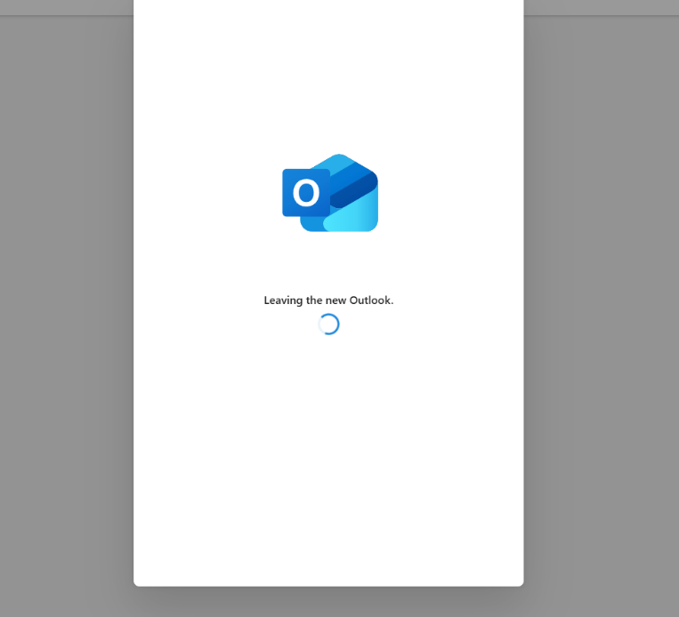

Searching windows for outlook shows two options, user would want to select “Classic” Outlook for the “outlook client upload” button to work:
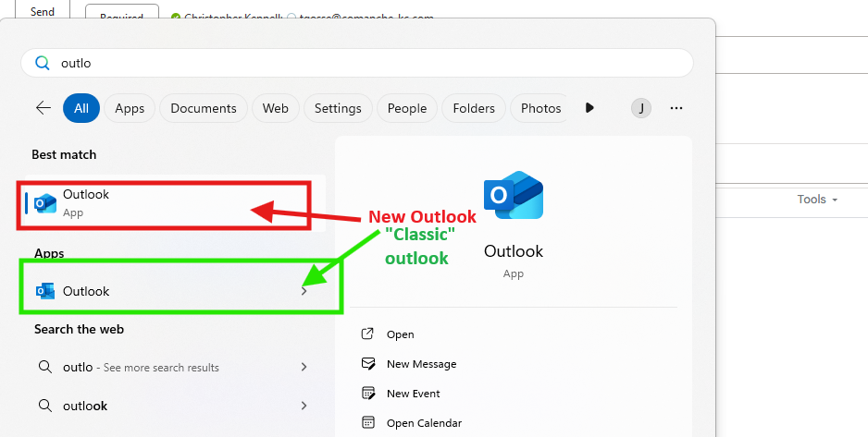

If user has “New” outlook, sending the file using this excel button may work better but user would have to type in email address of awpcre2o@modot.mo.gov :
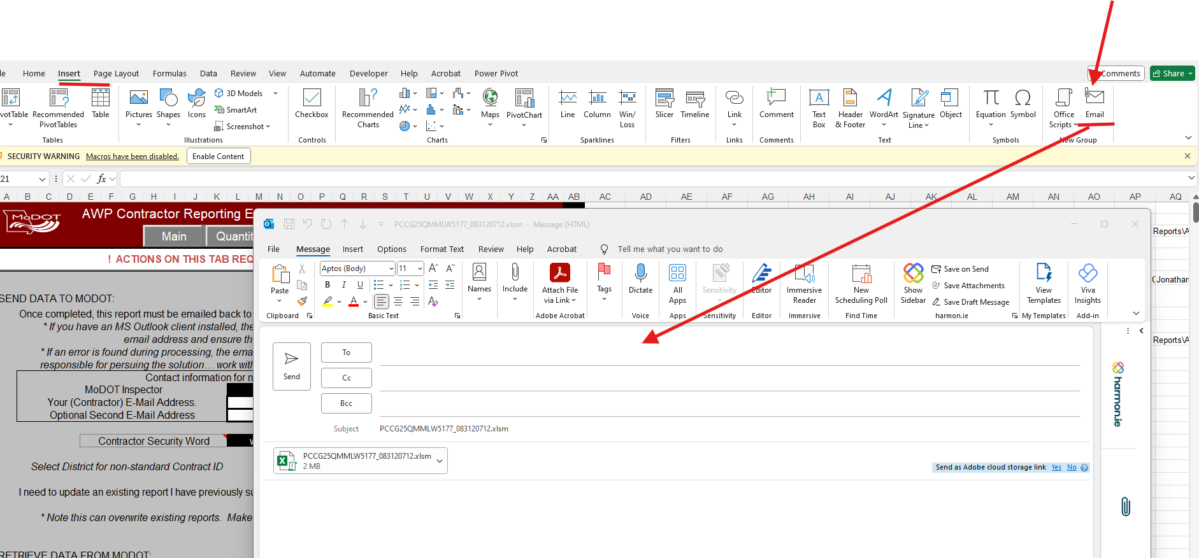
May have to add the “Email” button to the ribbon under excel options:
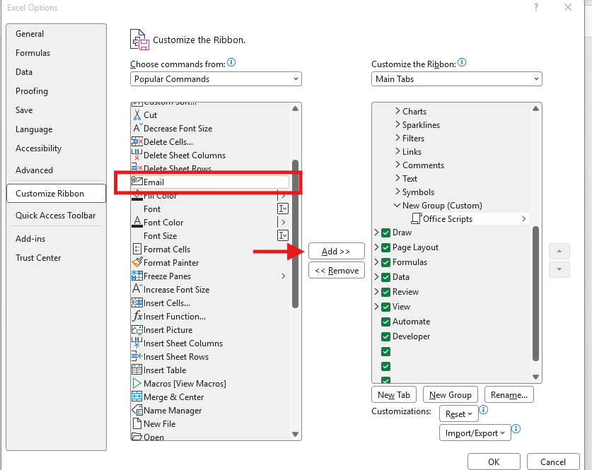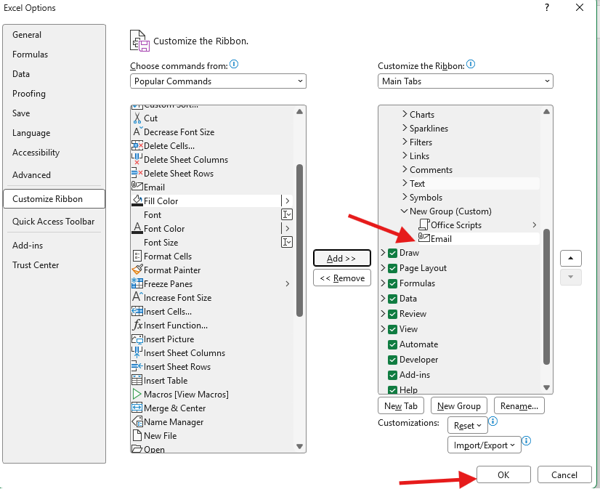

End of Quick Reference Guide

