Forwarding CRE2O Notifications
Quick Reference Guide

Contents
Contents 1
Outlook Rule to Forward CRE2O Notification Emails 2
Outlook Rule to move CRE2O Notification Emails forwarded to you 7

Overview & Purpose

Contractor Reporting Excel2Oracle (CRE2O) excel forms submit testing information into MoDOT’s database. When processed email notifications go out to the MoDOT inspector and email addresses listed on the Send/Sync tabs. This guide covers creating rules to automatically forward CRE2O notification emails.

Outlook Rule to Forward CRE2O Notification Emails
- Click “Manage Rules & Alerts…”
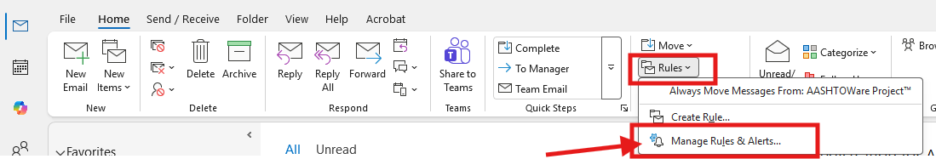
- Click “New Rule…”
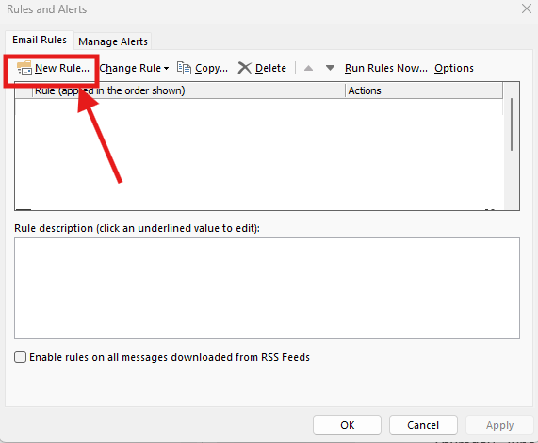
- Click “Apply rule on messages I receive” then “Next”
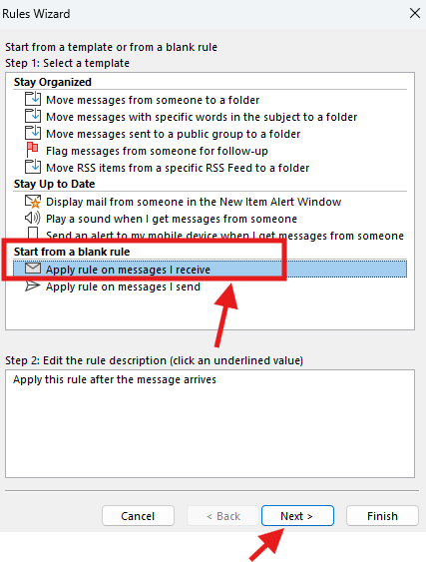
- Check “from people or public group”
  - Click link “people or public group” below
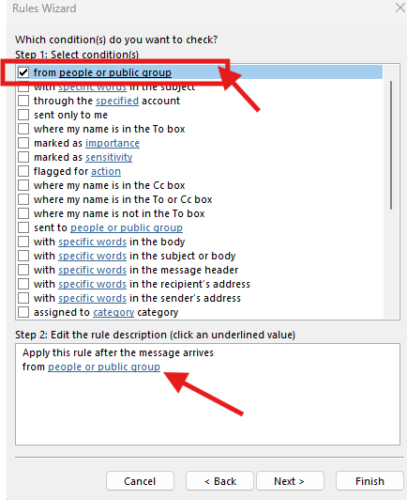
- Enter Excel2Oracle-CM@modot.mo.gov in the “from” field then click “OK”
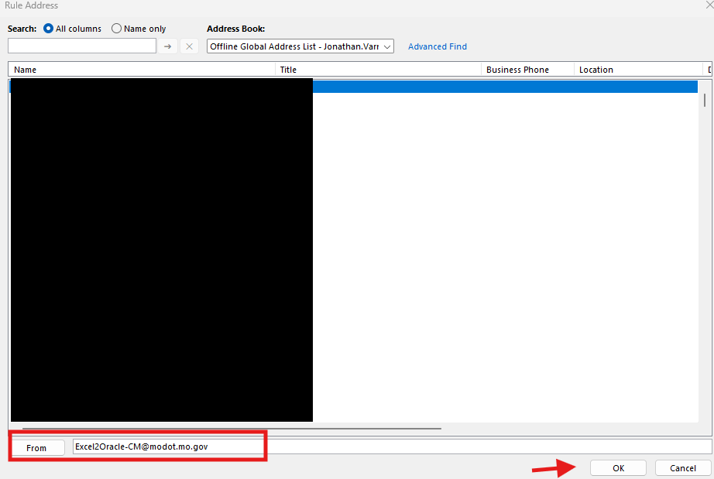
  - Then click “Next >”
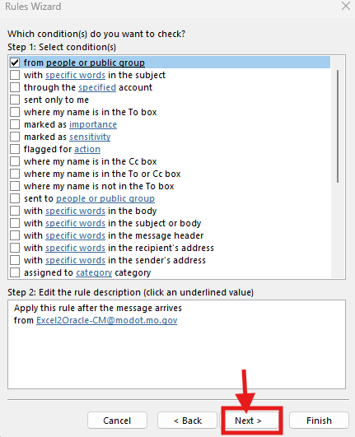
- Check “forward it to people or public group”
  - Click “people or public group” below
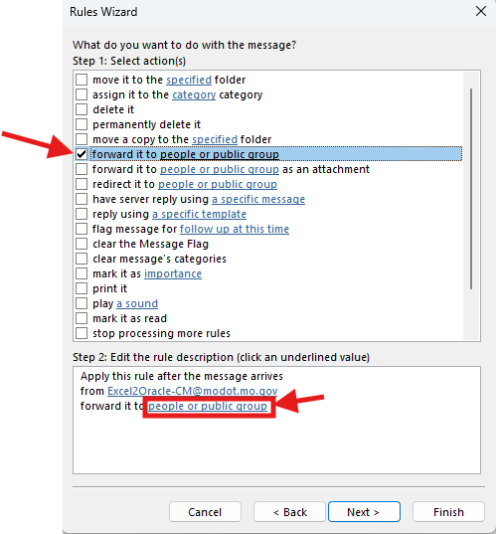
- Enter group email address you want the notifications forwarded to then click “OK”
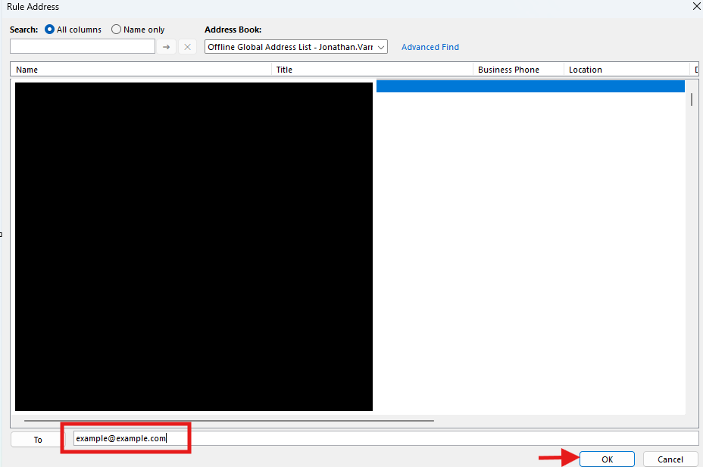
- Click “Finish”
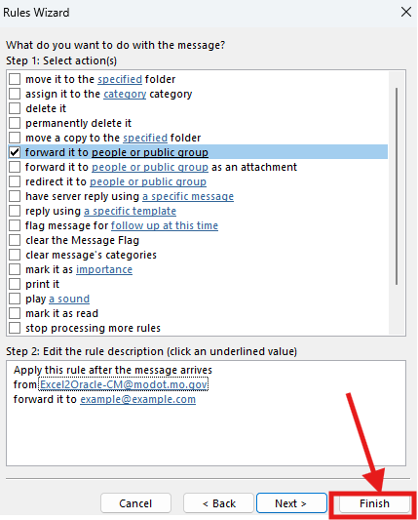
- Click “Apply” and rule should now automatically forward CRE2O notification emails to the selected email address
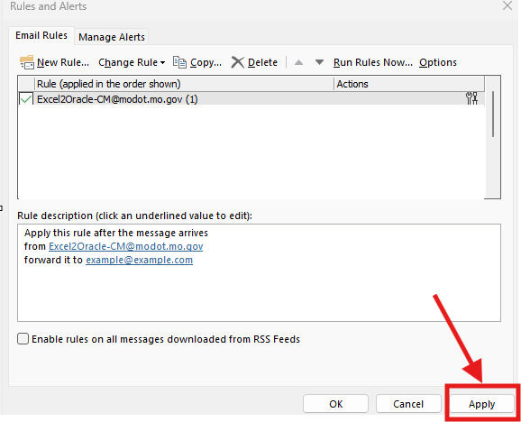

Outlook Rule to move CRE2O Notification Emails forwarded to you
Forwarding CRE2O notifications emails changes the email address to the email address of the user who forwarded the email. To sort these emails into a subfolder the rule needs to go by specific text in the subject line.

FW: Successful E2O Report
FW: Rejected E2O Report

- Click “Manage Rules & Alerts…”
- Click “New Rule…”
- Click “Apply rule on messages I receive” then “Next”
- Check “with specific words in the subject”
  - Click “specific words” below
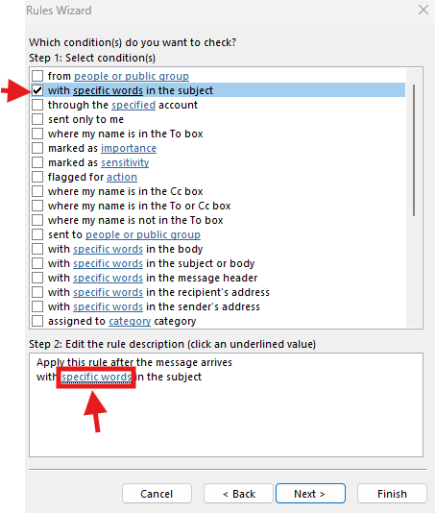
- Type in FW: Successful E2O Report and click Add
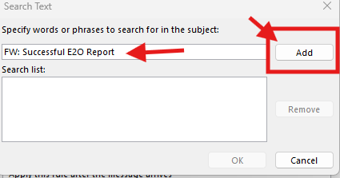
That will add the text in the “Search list”
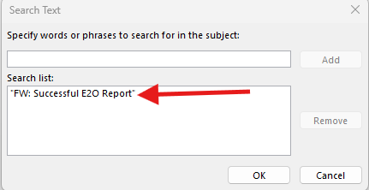
- Type in FW: Rejected E2O Report and click Add
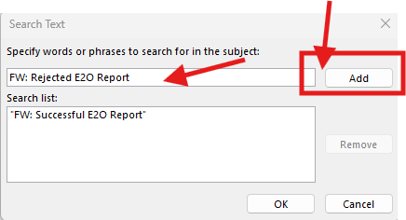
- Should have both values in the “Search list” as shown below, then click “OK”
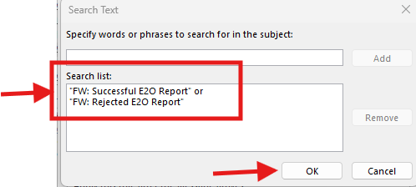
- Click “Next >”
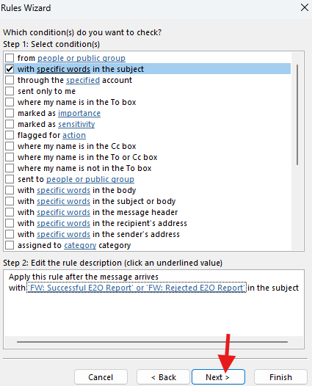
- Check “move it to the specified folder”
  - Click “specified folder” below
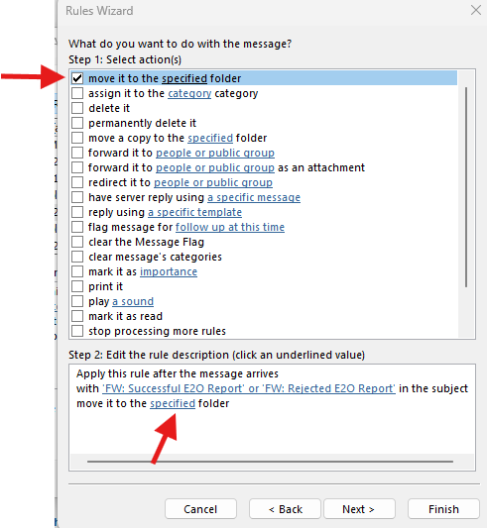
- Select the folder you want the CRE2O notifications moved to and click “OK”
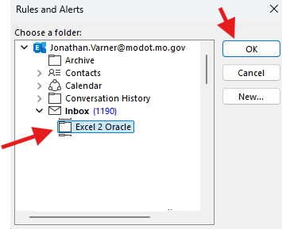
- Click “Finish”
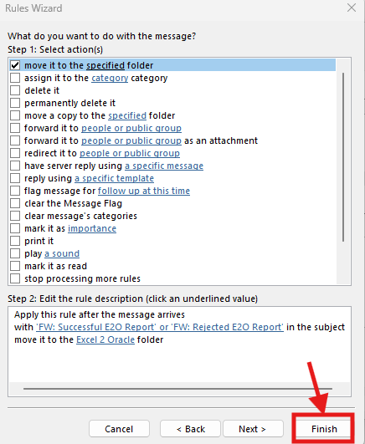
- Click “Apply”
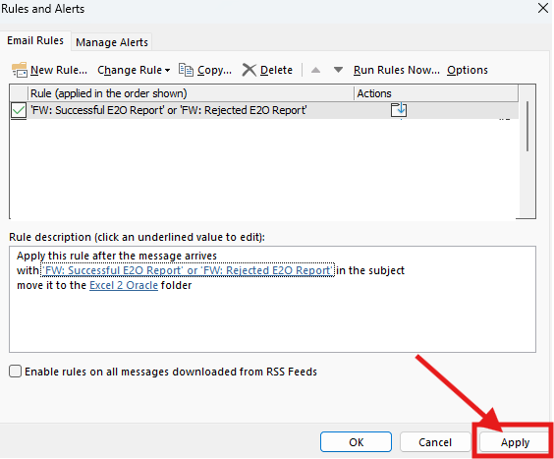

End of Quick Reference Guide

